Three Lochs Way Multi-use Notes

The Three Lochs Way is a 34.5 mile long distance route “which makes for a fascinating journey through place and time as it links an attractive necklace of communities around the Clyde Sea Lochs” (Loch Lomond, the Gareloch and Loch Long). Although developed and promoted primarily with walkers in mind, much of the route follows broad tracks and paths which are equally accessible on a bike or horse.

These notes have been produced by British Horse Society Scotland to identify which sections of the route are best suited to multi-use, and the location of restrictions. Whilst the focus is on horseriders, the information on obstructions is equally relevant to a wide range of other users including cyclists, walkers with pushchairs and people with mobility issues. Only features which may present an issue for experienced riders are noted below – shallow fords, bridges, cross drains, gates which can only be opened or closed if dismounted, rough ground, sheep and cattle are all part of riding off-road and so are not documented. Inclusion of a particular feature does not necessarily mean that it is impassable with a horse. Photos have been included where appropriate to help you assess for yourself whether a feature such as steps, a narrow footbridge, gate or gap less than 1.2m wide may present an obstruction to you.

The notes are intended to supplement route descriptions and other information already available from https://threelochsway.co.uk/ and other sources. All route users are responsible for deciding for themselves whether any particular section is suitable for their intended use, taking account of their own abilities, skills, fitness and experience, as well as season, weather conditions etc. Event organisers, groups or commercial operators considering using the Three Lochs Way are urged to contact the route managers.

Remember that whether on foot, cycle or horseback, rights of access in Scotland depend on access takers and land managers accepting individual responsibility for their actions. The Scottish Outdoor Access Code http://www.outdooraccess-scotland.scot/ offers guidance on what this means on the ground. Specific guidance for horse riders can be downloaded from http://www.bhsscotland.org.uk/responsible-riding.html. Courtesy, consideration of others’ needs and good communication are the key to sharing paths. Always pass others you meet along the trail at a walk, and elsewhere limit your pace to ground conditions and visibility. Riders need to be particularly careful to ensure they respect other users and clear up dung on more urban and narrow sections of path. Although waymarked throughout and easy to follow, it is still worth having a map with you – and making sure you know how to read it!

Balloch to Helensburgh
The barriers at either end of the foot/cycle bridge over the A82 west of Balloch have been removed so that horses can now use this bridge rather than the busy roundabout on the main road. The shallow steps leading up to the bridge from either end are passable with care with a horse or bike.
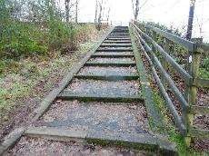

A new path has been created south of Ben Bowie linking Gouk Hill and Craigendoran. Horse riders should take care not to cause any damage by restricting speed to a walk.

The waymarked path through Red Glen east of Quarry Wood has recently been improved, as has the section through the wood but horse riders are asked to continue to use the farm track/forest road to avoid churning up the woodland path. Overhead branches may also be a difficulty for riders.

Helensburgh to Glen Fruin
There are numerous sleeper burn crossings through Blackhill Plantation (between Hill House and Drumfad Wood), which are easily passable with a horse or bike, but take particular care during wet or frosty weather when the sleepers become treacherously slippery.
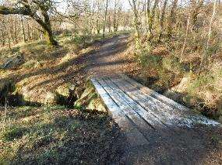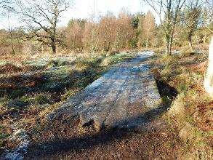

New self-closing bridle gates have recently been installed on the moorland section of the Highlandman’s Road.

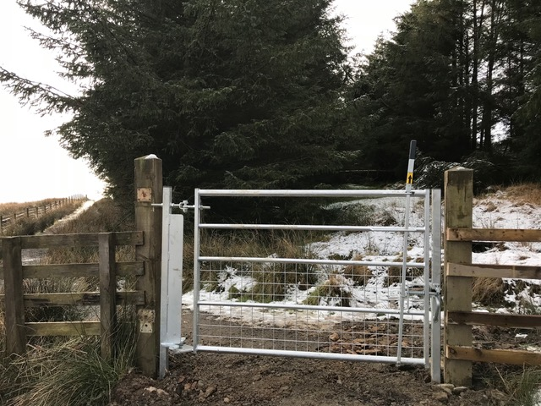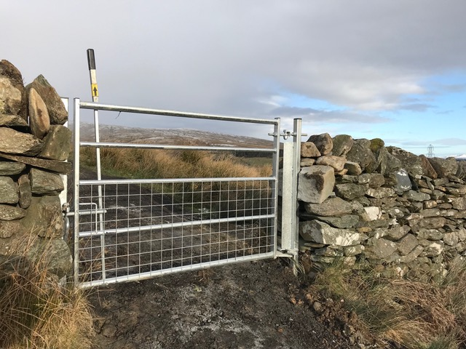

Glen Fruin to Garelochhead
At the time of survey, the gate alongside the cattle grid on the public road immediately south of the Fruin Water OSGR NS306865 was obstructed by a large boulder, seriously limiting the opening width of the gate. The boulder is too large to move and there is no alternative way around for horses or anyone else unable to cross the cattle grid.

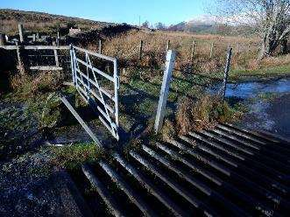

There are bypass gates or gaps alongside further cattle grids along the quiet public road through Glen Fruin, and new self-closing bridlegates have recently been installed at the entrance to Garelochhead ranges.

The link path down to Garelochhead is impassable with a horse due to fences and stiles and currently the only equestrian access to the village is via the public road system.

Garelochhead to Arrochar
North from Garelochhead, the main route continues without further restriction along a broad bitmac track with two-way self-closing bridle gates installed alongside a series of cattle grids. At the southern end of Glen Mallan, the route passes under the railway, with ample headroom for horses.

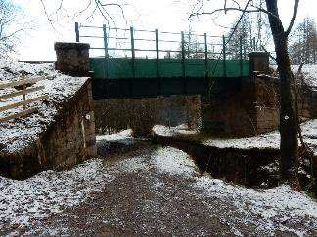

The path north of the railway has recently been upgraded – please take particular care to avoid damaging the lovely new surface, but at OSGR NS259967 the 90cm wide wooden footbridge (photo below) over the burn is unsafe and closed. Route managers are working with land managers Landmark to try to get a replacement. Meantime you will have to ford the burn at the point shown in the photo above a few metres east of the railway bridge.

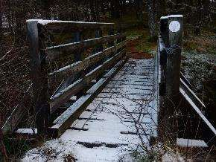

The path between the footbridge and the multi-use bridge further north over the Mallan Burn is narrow but easily passable with a horse or bike. North of Mallan Burn, the Three Lochs Way rejoins the forest road leading north through Glen Culanach to the public road east of Craggan. A new locked barrier with no unauthorised access sign has recently been installed across the western end of this track in Glen Douglas at OSGR NN283001. You can squeeze around this, but equestrian passage is impossible and at present there is no alternative way around this. Discussions are underway to install a self-closing bridlegate adjacent – check with the managers of the Three Lochs Way.

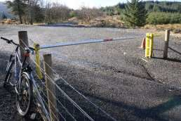

The track between Glen Douglas and Arrochar is broad with easily passable gates throughout. It is steep and stony in places and some sections are poorly drained. With funding assistance from NatureScot, Helensburgh and District Access Trust has provided an excellent new all purpose bridge over the previously difficult to cross Tighness Burn (photo below). As the approaches are steep, riders are advised to dismount when crossing the new bridge.

500metres or so north of the bridge a good path takes you down to the village of Arrochar, however the path goes under the railway line via a low “sheep creep” which is unsuitable for horses.

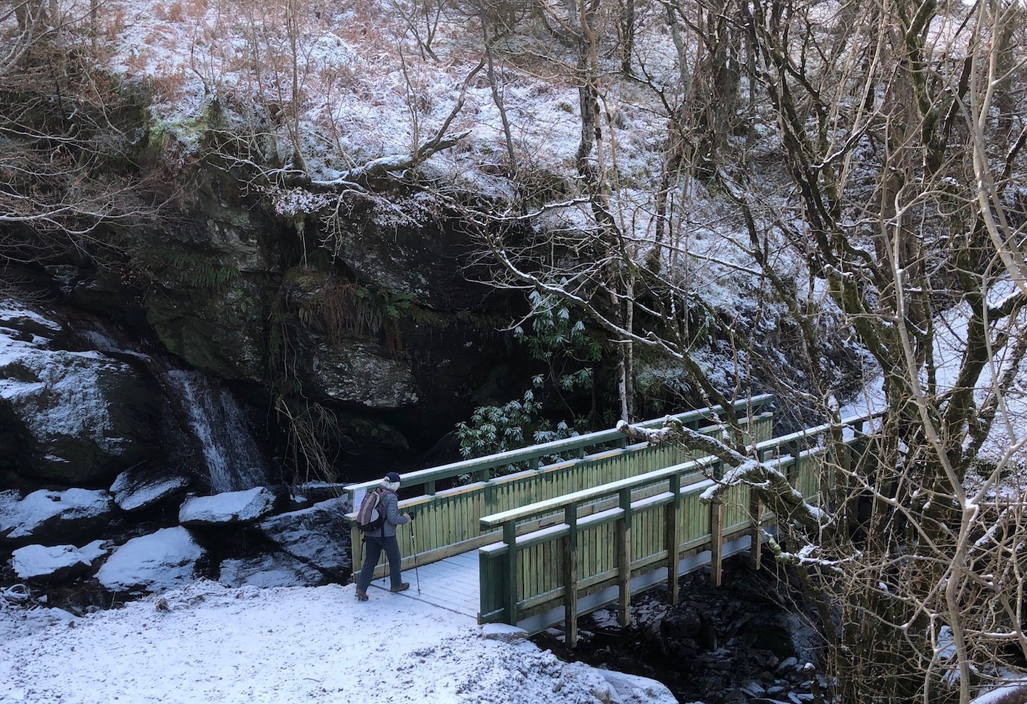

Arrochar to Inveruglas
A clearly waymarked forest path links from Tarbet, under the railway (with ample height clearance for horses) onto a farm track through Glen Loin, from where a track/firm path leads through to the hydro road at Coiregrogain which links down to the A82 at Inveruglas. Fords provide alternatives to footbridges, and the previous kissing gates have all been replaced with self-closing bridlegates. There is a narrow path parallel to the road alongside the A82.

Updated by Helensburgh & District Access Trust January 2021

